FOR THE KIDS – FROM 10am to Midday - Creative design and maker workshops for kids of all ages with the experienced team from Make and Meld. Exploring sustainable materials and having fun in a safe environment. For further information see their website - https://www.makeandmeld.com.au

Viv’s Farm Animals is an interactive animal farm, consisting of goats, sheep, alpacas, piglets, ducks, chickens and more. These animals will interact with people of all ages. They are soooo cute!

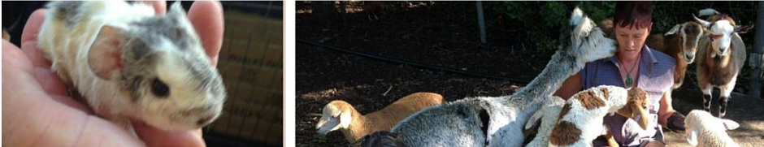

BOGI’s Own Produce SHOP – discounted prices for members – a great incentive to join, if not a member already! Check out the products at the Shed.

McLeods Agriculture (https://mcleodsorganicfertiliser.com)
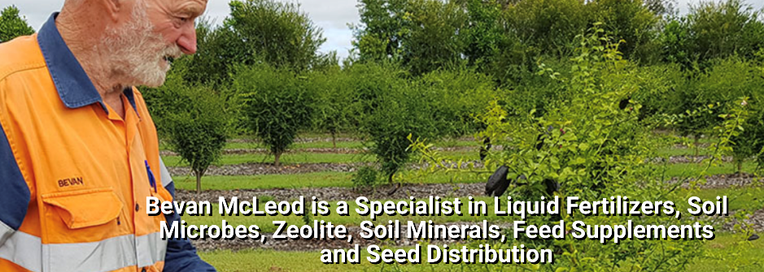

SPEAKERS TENT

9am - Keynote Opening Address Mr Arno King
Based in Brisbane, BOGI Member, Arno King, is a keen gardener, horticulturist and landscape
architect. He does garden talkback every Sunday on weekend breakfast radio 4BC and is a regular writer for a variety of magazines. Arno will talk about growing Queensland heritage vegetables - suited to our growing conditions. Heritage vegetables and organic methods are the perfect things to give gardeners confidence. Think, for example about pumpkins (Qld Blue, Beaudesert Blue, Oxheart etc), squash (pumpkin), lettuce (Simpson/first fleet etc). Arno will also talk about vegetables/fruit grown by indigenous people in Qld (rosella, luffa, snake bean, bitter gourd, lablab bean, gourd, rice etc) and be available to answer all your questions.

10.00am – 11.00am Jill Coombs – Searles – Soils aint soils! It all starts with the soil/potting
mixes.

Jillian Coomb is a qualified horticulturist and has been in the nursery and garden industry for
over forty years in retail, wholesale, indoor plants, head groundman, speaker, writer, and trainer.
This has given her vast experience in most areas of horticulture and this is something she want to pass on to everyone who is interested. No matter your skills level she tries to impart to you at least one thing you did not know. She has her Chemcert certificates and is happy to talk safe handling and applying chemicals, be it pesticides, fertiliser, trace elements or herbicides. Jillian is a member of the Horticultural Media Association and use to talking to crowds or individuals and loves to spread the gardening word. Jillian is the Garden Support Officer at Searles, a major supporter of the BOGI Fair.

11.00am – Join Arno as he returns to answer your questions and seeks out the best stalls
at the Fair this year.

12 noon - Alex Bauer – Shogun Tools – Techniques of Basic Pruning and selecting the right
tools for the job.

Alex and his wife Makiko own and operate Shoguntools.com, a Brisbane based supplier of
Japanese made garden and kitchen tools. Alex is also a qualified horticulturist and permaculturist who has been running his own gardening business for the past 10 years and has previously spent time as a horticulture instructor. Alex is particularly passionate about growing fruit and veg, as well as cooking and preserving his home harvest.

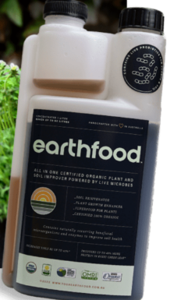
Earthfood (Bronwyn Holm) - https://yourearthfood.com.au
EARTHFOOD BENEFITS
For Domestic and Agricultural use
- 100% organic natural solution that is environmentally safe.
- Improves plant health and vigour.
- Improves plant ability to resist pests and diseases.
- Provides plant nutrients in a more readily absorbable form.
    - Can be used on any type of plant (indoors and outdoors in
almost any situation.
- Extends the harvesting period.
- Produces higher yields of fruit, vegetables, herbs and spices.

Dragon Grove Fragrances
Welcome to Dragon Grove Fragrances, where wild magic grows. This shop is a small business based in Brisbane, Australia. We specialise in beautiful natural perfumes that are all inspired by, and named in honour of, places in nature. You will also find other lovely natural creations such as body butter and soap. We passionately abide by an eco-conscious ethos. All of our products are vegan. https://www.etsy.com/au/shop/dgfragrances

BOGI BOOKS AND SEEDS

From BOGI Seeds stock up from a wide selection of seeds vegetable, Asian greens, herbs, flowers, all packed in convenient sizes at great prices. Get the best books to help the home grower. Best buy of the fair will be the Queensland Planting Guide at the special Fair price of $5.00 - All sales help support Brisbane Organic Growers Inc

BOGI Corner Store – Purchase a wide variety of potted plants from our members’ gardens at bargain prices.

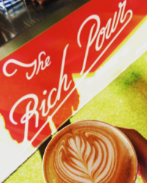

The Rich Pour Coffee Cart

Cappuccino, Latte When only the best will do.

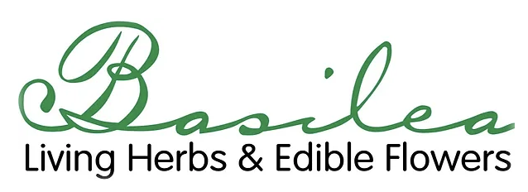
Spray-free, sun-hardy, culinary herbs, gourmet greens, and edible flowers seedlings and handpicked edible flowers. For further information - https://www.basilealivingherbs.com

Northey Street Farm
Nursery Products - Seedlings / Plants etc, Merchandise & Education Material - https://www.nscf.org.au

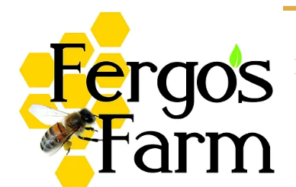
Fergos Farm – Raw Honey, Herb Infused Balms, Beeswax Candles. Fergo's Farm is a husband and wife team determined to do their bit in making this world a better place. We started by practising permaculture in our backyard, growing plants for bees, with a veggie patch for our families and friends. We have a firm policy: purchase organic options, ry-cycle everything we can, look for natural alternatives, use the sun for energy, don't waste water and bee good to your mother!
For further information - https://www.fergosfarm.com.au

Xing Jams and Luffa and a few plants (Stall 14)

Adrian Vos - Innovative large plastic pots & worm juice drums

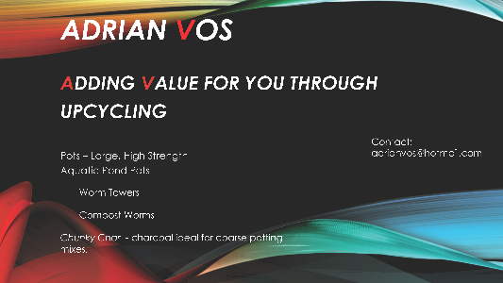

Monty Compost Co

Wasting less, doing more
Monty Compost Co is a Brisbane-based startup that was founded to help make composting easy and efficient for everyone through the power of technology. Waste less and create healthy organic fertiliser for your garden with Monty Monitor. For further information – go to https://montycompost.co

JULIE WELLINGTON

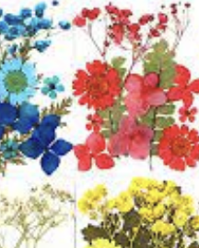
Cards, craft bits & pieces, pressed flower pictures, cuttings

Two Bears Ceramics

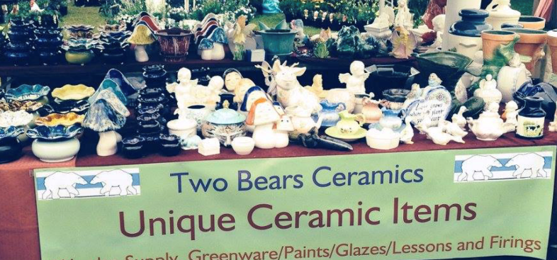
Email at info@twobearsceramics.com

Urban Valley Mushrooms

Fresh mushrooms, Mushrooms Kits (https://urbanvalley.com.au/pages/fresh-mushrooms )
We currently supply chefs from Brisbane region, to the Sunshine Coast in the north, out west to Toowoomba, down to the Gold Coast and as far south as Byron. For wholesale inquiries, please get in touch at info@urbanvalley.com.au

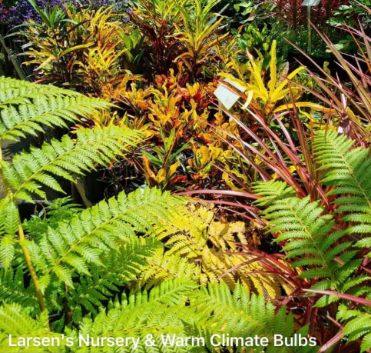
Larsens Nursery and Warm Climate Bulbs

https://www.facebook.com/LarsensWarmClimateBulbs/

Rosalie Village Garden Centre – Seedlings, Herbs, Fruiting Plants, Potted Colour, Landscape and Indoor Plants, Fertilisers, Pots. https://www.facebook.com/people/Rosalie-Village-Garden-Centre/100074454369276/?paipv=0&eav=Afb-jyGa-gnStQez2pv4Pt29QKVfp5H-gOYCPI9g9_JyKnCYzEyesopPNEghxtF5xVE&_rdr

Indie Bakehouse (https://indietreats.bigcartel.com) - Our small-batch baking crew makes sustainable, artisan sourdough, custom celebration cakes & nourishing brekkie bars.
Our lovely loaves are raised in Brisbane, crafted by hand using sustainable local flour.

JA’s Herb Nursery
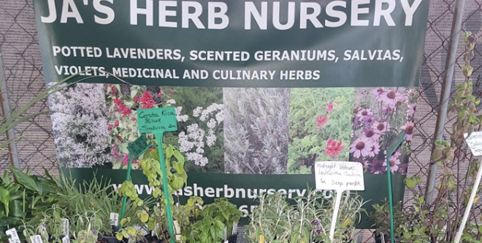
https://www.facebook.com/sber2126/

OutMyGarden

Bee & Butterfly attracting plants, hard to find shrubs, bulbs, creepers, foliage & tropicals.

Phil’s Organics

Organic fertilisers, comfrey plants, seedlings and worm farms.

www.Mopheadbylinda.com
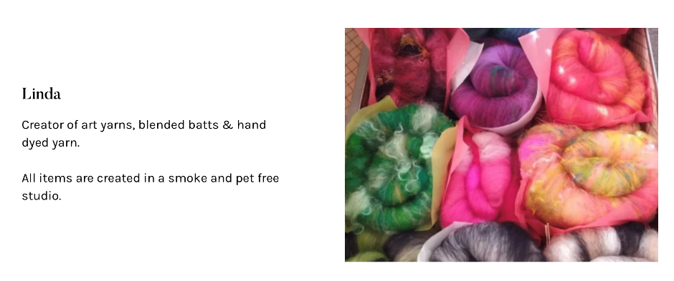
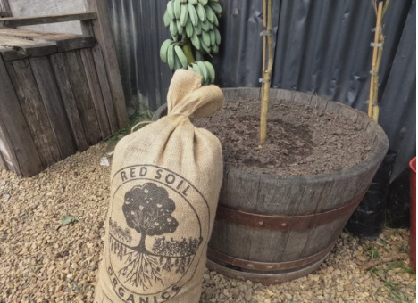
Red Soil Organics & In the Loop

Red Soil Organics Specialises in high quality organic composts and mulches that are sure to impress and achieve wonderful results in your garden! Also, Worm Castings.
https://www.facebook.com/intheloopbne/
https://redsoilorganics.com.au

Stall 41

FORBIDDEN FRUIT
http://www.forbiddenfruitsnursery.com.au
A wide variety of fruit, nut and citrus trees, check our website for plant availability. Email info@forbiddenfruitsnursery.com.au if you want us to bring a particular plant for you to the fair.

BOGI CAFÉ – Inside the Hall – Enjoy fresh, home made delights, catch up with friends over a hot or cold beverage.

Larvalicious
https://larvalicious.com.au
Soldier fly products, fertiliser and pet food
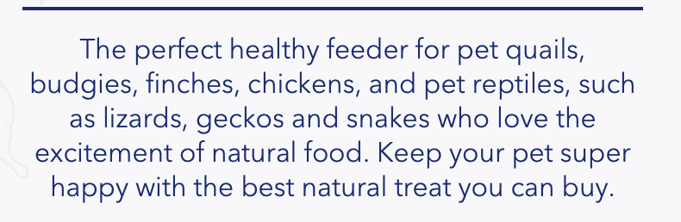

BOGI Member, STAN CAJDLER will be displaying solar & low tech devices and providing advice on cooking and garden items.

Stall 53 – Shogun Tools
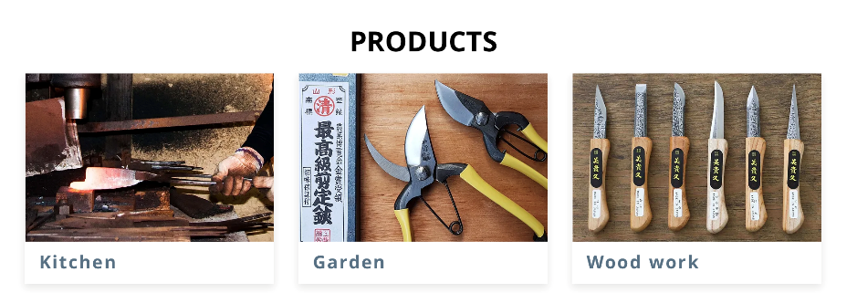

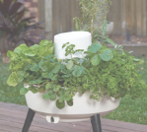
Composta. – A Worm Farm and Garden All in one. Perfect for gardens big and small. https://composta.myshopify.com

Mount Cotton Organic Collective - https://www.mountcottonorganiccollective.com

